Ambiance Hardware Assembly
Ambiance GitHub Repository: https://github.com/simonnkm/Ambiance
Ambiance WILDLABS Inventory: https://wildlabs.net/en/inventory/products/ambiance

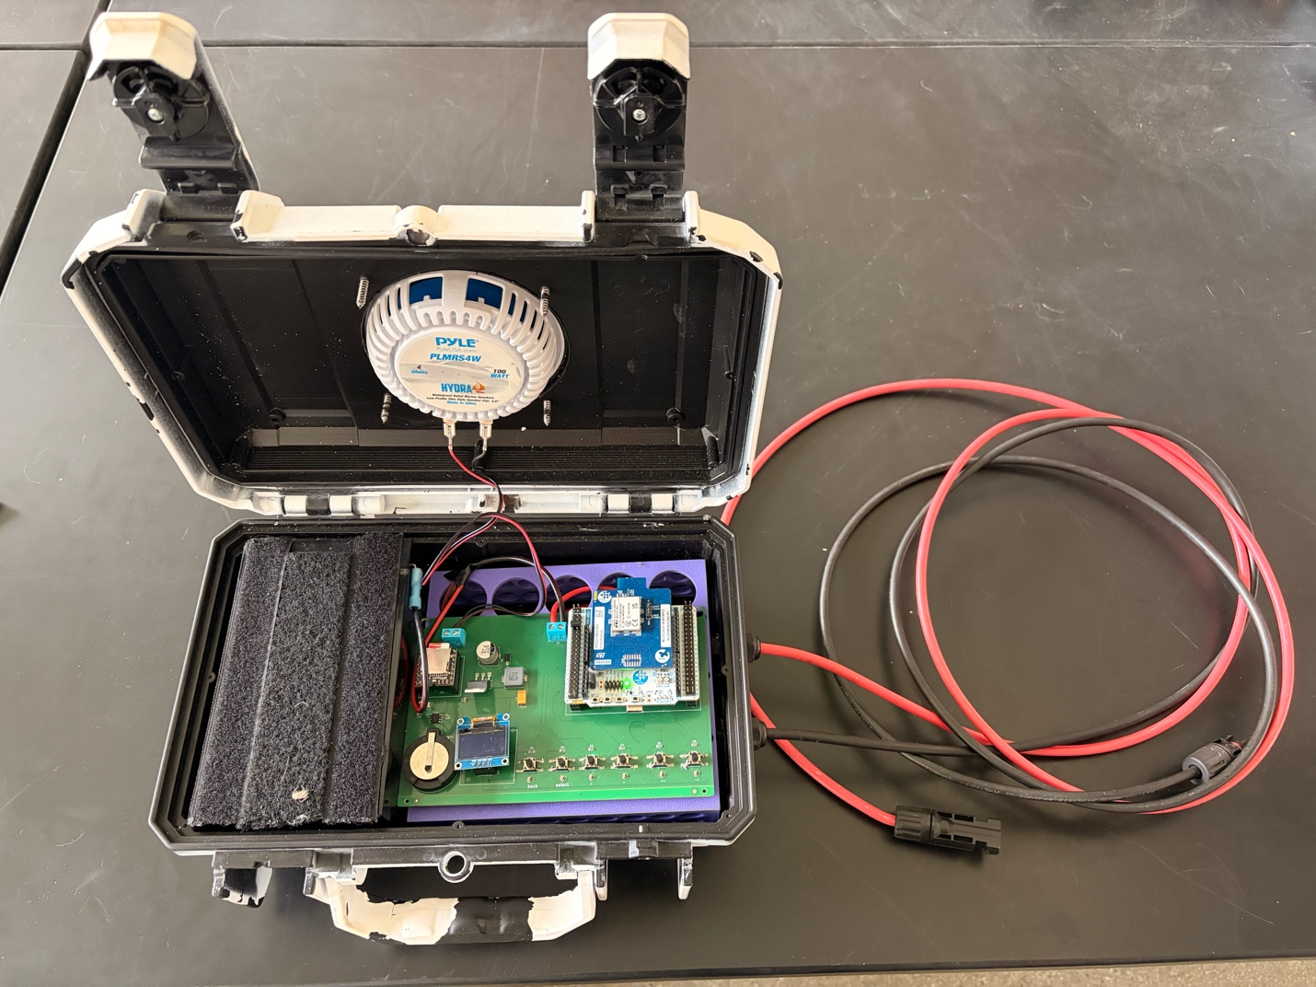
Figure 1: Overview of assembled Ambiance unit, solar panel not displayed.

Tools Needed:
- Electric Drill
- 3/4 inch and 5/16 inch drill bits
- 7/16 inch tap
- Flathead and Phillips screwdrivers
- 4-inch hole saw
- Wire strippers and powerpole crimpers
- Soldering iron and heat gun kit
- Optional: 3D Printer for internal bracket, reflow oven for efficient PCB assembly

Parts needed:
Printed Circuit Boards:
Boards can be ordered from PCBWay with or without components using this link: https://www.pcbway.com/project/shareproject/Ambiance_Playback_Speaker_8d6dbe2b.html.
*When soldering on components or inspecting soldered boards received from PCBWay inspect the orientation of each component with polarity before connecting to power to ensure the board will not be fried inadvertently. See photo below for component orientation. The boards are designed to be assembled in reflow ovens, however hand soldering will produce the same result but take longer (see here for a tutorial on surface mount soldering: .

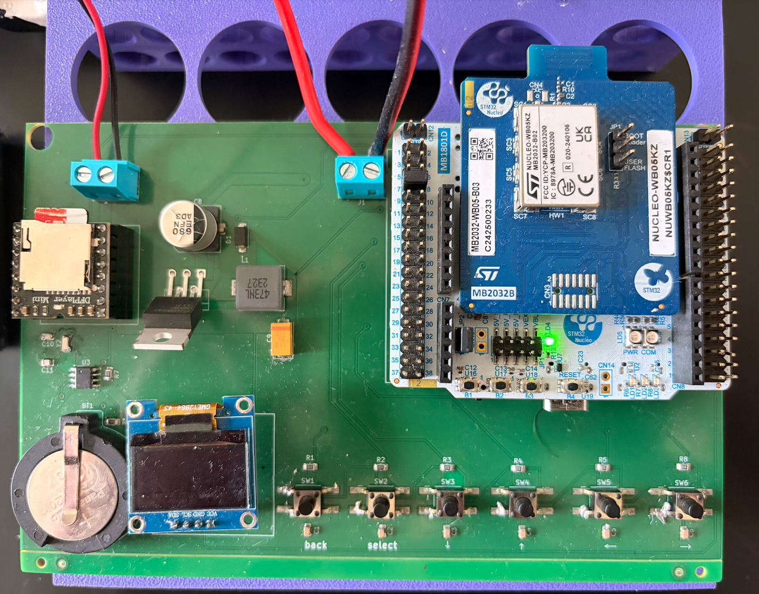
Figure 2: Detail of PCB components and their orientation.

Several components are placed on headers so that they can easily be removed and replaced in the field without losing the entire board:
- OLED 0.96 inch i2c Display Module (https://shorturl.at/1rHQw)
- DFPlayer Mini DFR0299 (https://shorturl.at/bgHfG) + MircoSD card of choice
- STM32 (NUCLEO-WB05KZ) microcontroller (https://shorturl.at/Fxyu1)
**To install these components on headers position the components in the correct orientation – see images below and apply equal pressure across all pins to slowly press the component towards the PCB until all pins sit nice and flush to the top of the header.

Packaging and Circuitry:
- Seahorse SE230 case (or third party equivalent, e.g., Fuerte Cases): https://tinyurl.com/93t86caj
- Exterior: 11.9 x 8.5 x 4.8" (30 x 22 x 12 cm)
- Interior: 10.6 x 6.1 x 3.9” (27 x 15 x 10 cm)
- Weight: 2.15 lbs (.98 kg.)
- If packed efficiently, 12 of these can be packed into a duffel bag and checked on an airplane in terms of volume.
- Pyle Marine Speaker (2 per pack, 1 per unit): https://tinyurl.com/3chzfc73
- 4-inch, 100-Watt, come with their own o-rings, mounting screws, and wiring
- 40-Watt, Semi-flex, monocrystalline solar panel
- Best sourced locally. This size solar panel can charge the LFP battery listed below in a couple of hours and is sufficient to charge said battery to full on overcast and rainy days on the equator. Depending on local weather and solar exposure, larger or smaller panels may be better suited to local conditions. We found semi-flex solar panels lighter and easier to anchor to the tree canopies we were deploying the Ambiance units on. Panels with gromets are great for looping zip ties through.
- Lithium Iron Phosphate battery (12V, 7-9ah, 6 x 3 x 3.5 inches)
- Best source locally. Batteries this size were capable of maintaining playbacks broadcast at SPL of 80dB at 1m for 10 hours out of a 24-hour cycle (40:60 duty cycle) for 2 days without losing power. Larger or smaller batteries may be better suited for more or less demanding playback schedules.
- PowerWerx MPPT Solar Controller: https://tinyurl.com/y4y3smp4
- This is an incredibly compact, efficient, and reliable solar controller for a great price point. Any MPPT solar controller would suffice but larger controllers will likely require larger enclosures.
- 30 Amp Anderson Powerpole Connectors (1 pair per unit): https://tinyurl.com/5ar4kemr
- 14-16 AWG Insulated Female Spade Connectors (2 per unit): https://tinyurl.com/4xrdy39s
- PG7 Cable Glands (2 per unit): https://tinyurl.com/mw3t4rwh
- 16 AWG Insulated Wire: https://tinyurl.com/tm8k5wtc
- 6mm, 3:1 shrink factor heat shrink (or electrical tape): https://tinyurl.com/4zrc499c
- Thread sealer, silicon, or epoxy that binds plastic to seal cable glands
- Optional: 10AWG insulated wires (e.g., https://tinyurl.com/yc46swsu) and MC4 Connectors (https://tinyurl.com/399v7bjb) for extension cables between Ambiance unit and solar panel.
***Units are modular with the exception of the PCB so locally available parts can be used to replace items listed above.

Assembly Instructions:
1. It is important Ambiance packaging to be light in color, this greatly reduces the amount of heat absorbed into the interior of the unit. Due to the weatherproofing, there is no ventilation into or out of the packaging and earlier Ambiance generations that utilized dark colors resulted in melted lithium iron phosphate batteries when deployed at tropical sites on the equator. Enclosures can be ordered from third-party manufacturers in white or other colors with high albedo, or if this is not an option locally, enclosures can be spray painted white.

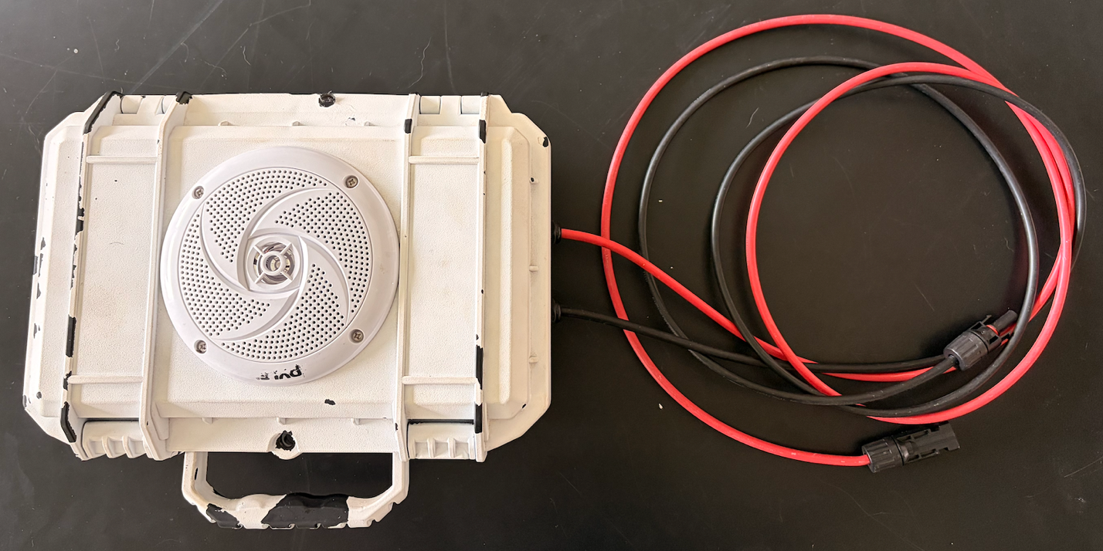
Figure 3: Exterior of Ambiance SE230 case painted white to reduce heat absorption in the field.

2. Start assembly by drilling the necessary holes in the Seahorse SE230 case. Mark the center point on the upper lid of the SE230 – this will need to be precise as there is only 1-2mm between either side of the 4” Pyle speaker and the raised bevels of the SE230 and use the 4” hole saw to drill a hole at the center point. Next, drill two pilot holes for the positive and negative cables coming from the solar panels using a 5/16” bit on the lower base of the SE230. This should be on one of the short sides of the SE230 and low enough that the incoming solar panel cables will sit below the bracket that the PCB sits on. This will also be on the opposite side the battery sits on. After drilling pilot holes, use the 7/16” tap to drill a larger threaded hole through the pilot holes. Python locks (i.e., cable locks used to lock camera traps to trees) are useful for securing Ambiance units to trees, poles, etc. If you will be using a python lock to secure the Ambiance unit you will need to use a 3/4” bit to widen the preexisting hole on the SE230 and drill an additional hole on the plastic bezel near the hinge. After drilling these two holes, python locks can be threaded through to secure the unit.
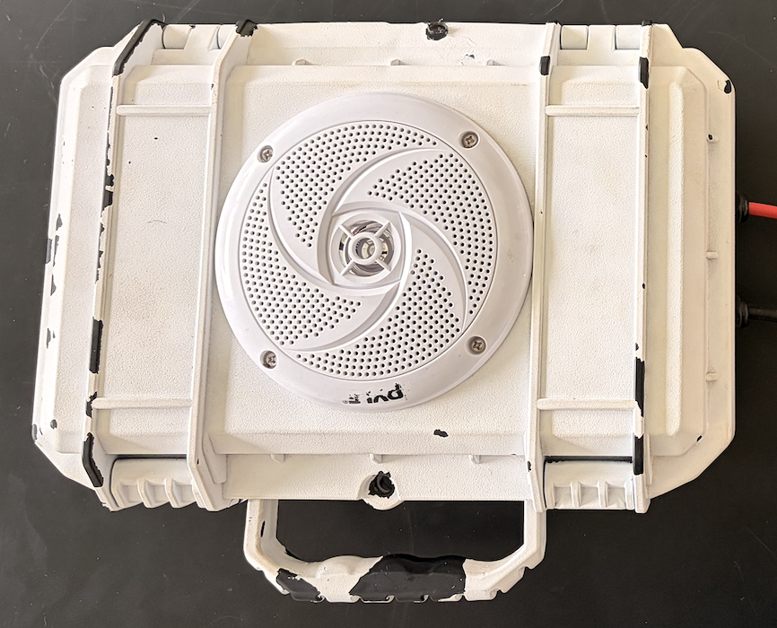
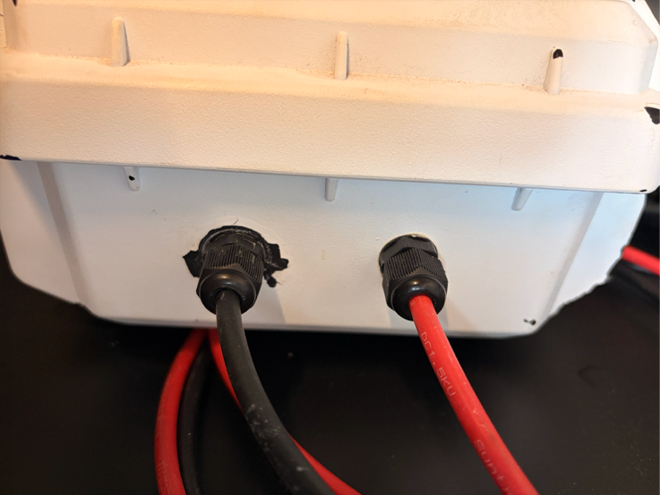
Figure 4: Detail of Pyle speaker and cable gland fittings.

3. Attach the o-ring that comes with the Pyle speaker around the 4” hole in the lid of the SE230 (sticky side down) and place the Pyle speaker so that the speaker terminals are positioned pointing towards the hinge of the SE230, then drill the four 1” screws through the Pyle speaker, o-ring, and SE230 case. To attach the cable glands, simply screw them on with the gland facing outwards. Apply thread sealer to the thread of the cable gland before screwing the two sides together. Allow time for the thread sealer/epoxy to cure an appropriate amount of time based on the material used before continuing with assembly.

4. Constructing the wiring harness involves cutting two lengths of 16AWG wire – one ~8” and another ~6” - for both the positive and negative connections. Strip both ends of both lengths of wire and and strip about half an inch of insulation midway along the 6” wire. Braid one end of the 8” wire around the stripped center of 6”, solder them together to form a Y-shape (see here for a tutorial: https://www.youtube.com/watch?v=4xUBRMgcVhc), and use heat shrink (applied with a heat gun or lighter) or electrical tape to insulate the joint. On the other end of the 8” wire, crimp a female spade connector. On the end of the 6” wire that forms the other top of the Y, crimp an Anderson Powerpole connector (see here for a tutorial: https://www.youtube.com/watch?v=bZHh3nWXtkw). Repeat this process once more for the other half of the wiring harness. Be sure to insulate any exposed wire to prevent short circuits during operation.

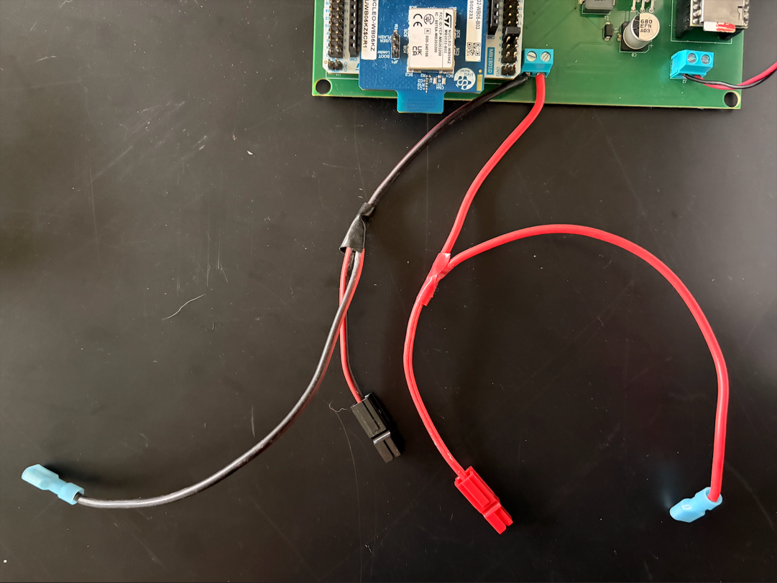
Figure 5: Detail of wiring harness and attachment to screw terminals.
5. Whether utilizing extension cables (we found 3m extension cables allowed for flexibility when installing Ambiance devices in tree canopies as well as posts on farms and livestock corals) or attaching directly to positive and negative terminals solar panel (normally come with .5m cables), cables will need to be threaded through the cable glands and into the SE230 case before installing MC4 connectors, given the diameter of the MC4 connectors (see here for a tutorial: https://www.youtube.com/watch?v=VrKYlQPHfno).

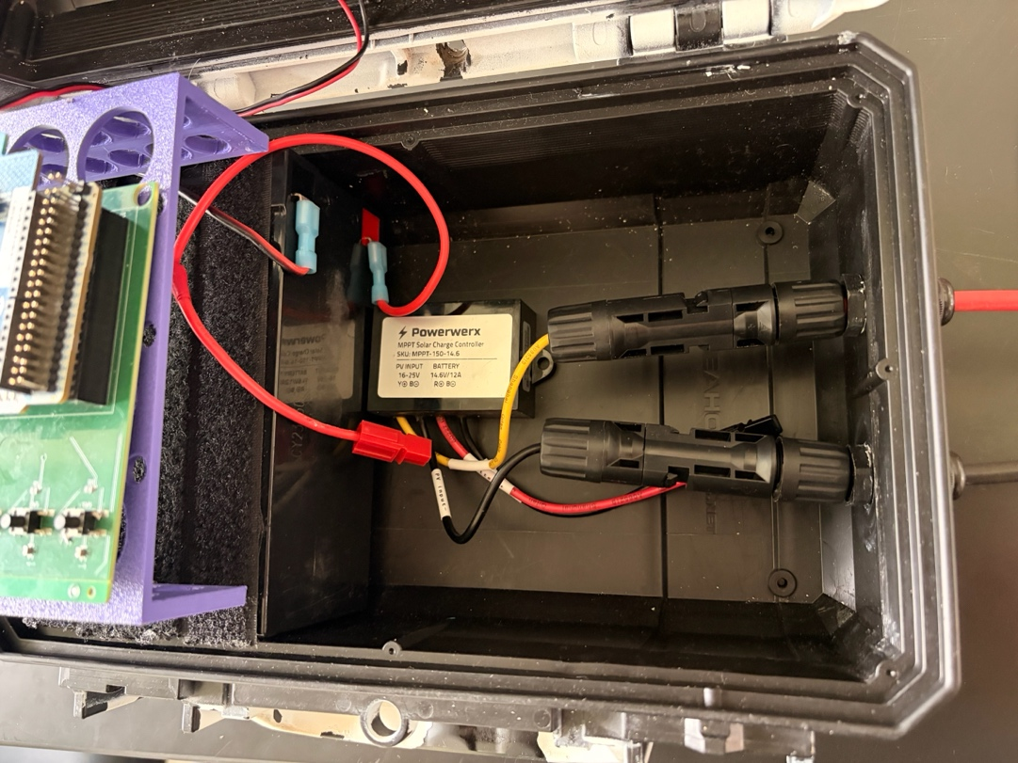
Figure 6: Detail of MC4 connectors correctly installed inside the SE230 case and attached to the solar controller. They should fit underneath the internal bracket the PCB is mounted to.

6. Use a 3D printer to print the internal bracket (Ambiance Bracket.3mf under Assembly_Materials on the GitHub repository, or find it on Bambu Labs’ Maker World: https://makerworld.com/models/1722885) or utilize a suitable alternative that will lift the PCB a couple of inches off the floor of the Ambiance unit so that there is space for the solar panel cables and MPPT solar controller underneath the bracket.

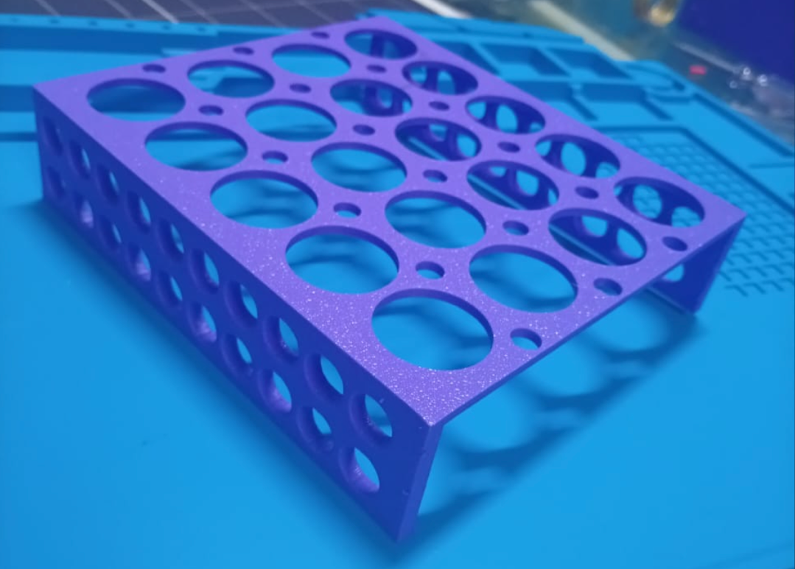
Figure 7: Detail of internal mounting bracket.
7. We found Velcro to be an effective and economical means to secure various components inside the SE230 case. Secure the LFP battery and MPPT solar controller to the floor of the SE230 case using Velcro. When laid on its side, with the terminals oriented laterally towards the interior of the SE230 case, the battery fits snugly with the interior dimensions of the case, reduces the length of the wiring harness, and provides space for the solar controller. The battery should be installed opposite the solar cables. Now attach the solar cables to the solar controller. It is worth taking the time to double check that negative matches negative and positive matches positive so that nothing shorts out when connected to power. Now attach the wiring harness to the screw terminals on the PCB closest to the STM32 microcontroller using a screwdriver. Make sure you hold the screw terminals to relieve the torque force applied to the screw terminals from the screw driver, otherwise the solder joints on the screw terminal will break. Also take time to confirm positive (red in the image below) and negative (black in the image below) are in the correct positions. You can also utilize the wire provided in the Pyle speaker kit to attach the positive and negative speaker terminals to the second screw terminal in the corner of the PCB, taking time to ensure positive and negative terminals are oriented correctly. Cutting these wires to ~12” in length is sufficient to ensure the SE230 case opens and closes without pulling on the speaker or the screw terminal. Thread the wiring harness through the large holes in the bracket and fasten the positive and negative Anderson Powerpole connectors to their corresponding terminals on the solar controller. Secure the PCB to the internal bracket with Velcro. Lastly, connect the female spade connectors to the LFP battery terminals. At this point if everything has been assembled correctly and the battery is charged. There should be an LED lighting up on the STM32 microcontroller and a menu displayed on the OLED screen (assuming you have flashed the STM32 microcontroller with the proper code, see below). Test the PCB to ensure all of the buttons work for navigating around the menu, if not you may need to resolder some of the joints on these buttons. Multimeters are useful tools for diagnosing faulty circuits. Also ensure you set the correct date and time for the Real Time Clock to keep track of.

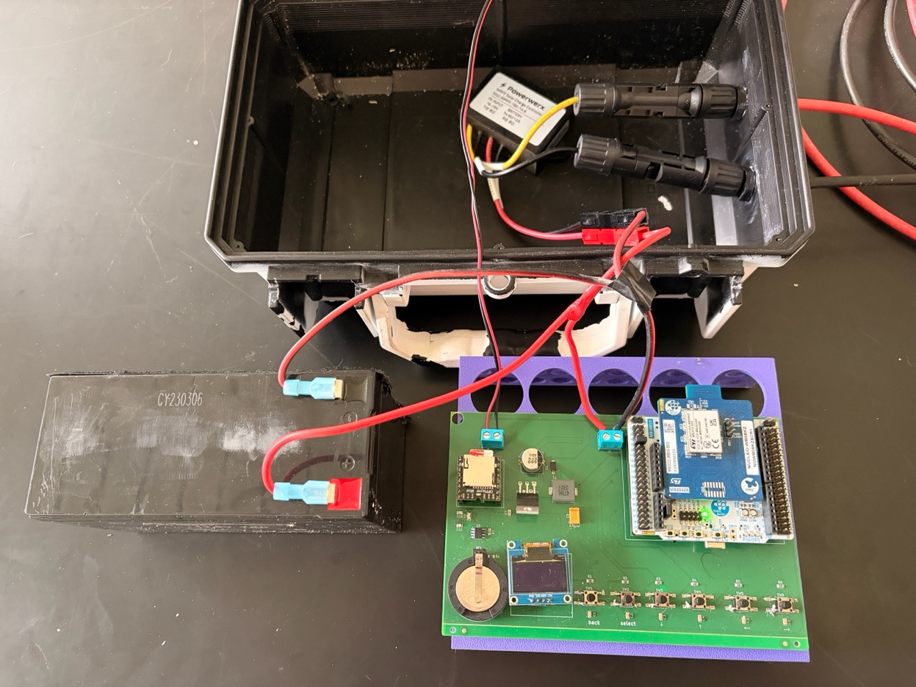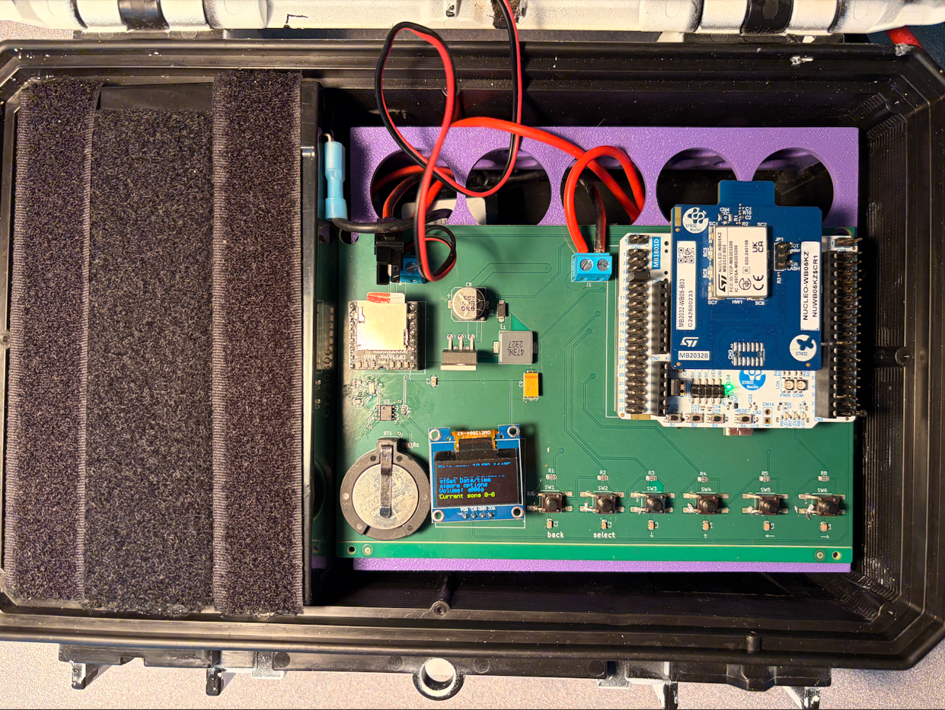
Figure 8: Overview of all internal components wired together (top) and then positioned as intended to be deployed (bottom).

8. For information on initially flashing STM32 microcontroller, see Ambiance-main on the GitHub repository.

9. For information on assembling and using the Ambiance GUI that allows for efficient Bluetooth programming of playback schedules and other unit parameters, see Ambiance_GUI in the GitHub repository.

10. The DFPlayer mini is extremely fickle so read carefully. It is programmed to accept .mp3 or .wav files on a microSD card formatted in FAT32. Tracks need to be labelled 001, 002, 003, etc. within a playback treatment folder. Playback treatment folders need to be labelled 01, 02, 03, etc. There is only one level of folder organization possible on the DRPlayer mini so do not nest playback treatment folders inside other folders. Tracks are not copied onto the microSD card in alphanumeric order, so the microSD card needs to be sorted through open source software each time the microSD card is inserted into a computer – otherwise tracks will play out of order and out of treatment folders and loops may break. This process also removes hidden files that operating systems automatically load onto microSD cards. These programs are useful for Mac (FatDriveSorter: https://fat-drive-sorter.netlify.app) and Windows (FATSort: https://sourceforge.net/projects/fatsort/). Side note: Audacity is a useful open source software for modifying audio file tracks so that recorded material can broadcast at a SPL of 80dB at 1m (this volume is about the maximum you can force out of a 4” 100 Watt speaker and in an open environment like a grassland you can expect sound to travel audibly for approximately 175m).

11. Schedules can be set either through the buttons on the PCB or through the Ambiance GUI. Schedules are programmed for specific times of day over specified days of each month. To set a schedule across multiple months, you would need to input the same treatment schedules for each month. Treatments can start and stop in 15-minute increments (00, 15, 30, 45 minute of every hour). Multiple treatments can be scheduled for any given 24-hour period to accommodate treatments germane to different parts of the diel cycle, as long as they are not programmed to overlap each other. Once a playback treatment folder is scheduled, tracks from inside that folder will loop through randomly during the prespecified time. Duty cycle ranges from 1-100, where 100 represents constant playback and 1 represents a schedule where 99% of a scheduled treatment period will remain silent and playbacks will only occur during 1% of that period. Duty cycle is calculated and realized based on the previous track length. E.g. on a duty cycle of 40 (40% on, 60% off), a 4-minute track would play and be followed by 6 minutes of silence, then it might be followed by a 2-minute track and subsequent 3 minutes of silence, and so on and so forth. See GUI readme file for more details.

